sConfigure and verify IPv4 Address

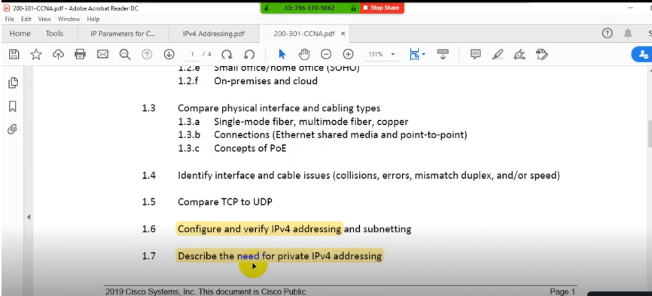

**Configure and verify IPv4 Addressing**

* IP stand or Internet Protocols internet means international Network.
* Protocols are set of rules and regulation.
* V stand for version, where VI, V2, V3, V5 and V6.
* VI, V2, and V3 were all test versions that were improved.
* IPv5 also called the internet steam protocol developed in 1980s.
* IP address is a logical address for a Network Adapter.
* The IP address uniquely identifies computers on a TCP/IP Network.
* IP address is a numeric identifier that is assigned to a device for communication.
* The designers of the Internet Protocol defined an IP address as a 32-bit number.
* IPv4 address consists of 32 bits, which limits the address space to 4294967296 (232).
* IP address consists of four decimal numbers, which separated by dots or decimal points.
* Hence, we also called IP Address version 4 dotted-decimal notation.
* For example, 192.168.1.0 is an IP address written in dotted-decimal notation.
* The binary version of 192.168.1.0 is 11000000 10101000 00000001 00000000.
* Each decimal numbers of IP address represents 8-bit, and called an octet.
* Hence, an IP address represents 32-bit (or 4 bytes).
* The range of each octet is between O and 255.
* IPV4 address start rom 0.0.0.0 and end with 255.255.255.255.
* It is also called 32 bit, logical, network, variable, software, layer 3 address.

IPv4 address space can be subdivided into five classes.

**IPV4 Classes**

* IPv4 address space can be subdivided into five classes
* IPv4 class are class A, class B, class C, class D, and class E.
* IPv4 each class consists of subset of the overall IPv4 address range.
* IPv4 class A, class B and class C used for Unicast ranges.
* IPv4 Class D used for Multicast Range.
* IPV4 Class E reserved for Research purpose.
* IPv4 Class E network is reserved for "experimental use".
* IPv4 Class E should not be assigned to host devices.
* IPv4 address range from 0.0.0.0 through 0.255.255.255 cannot work.

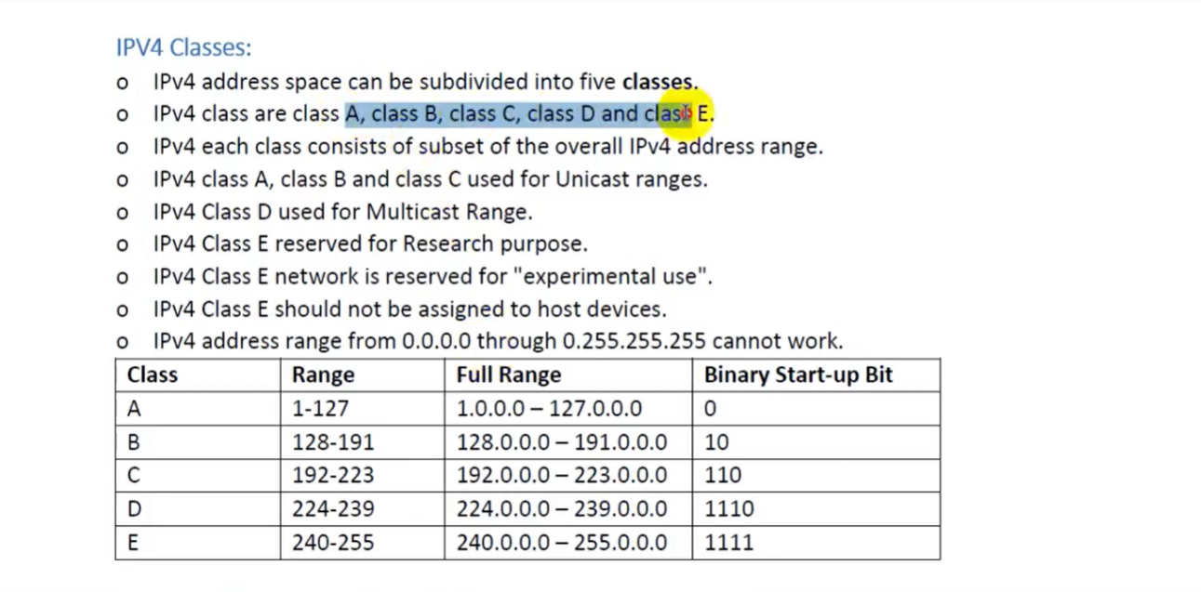

**Loopback Address:**

* Address beginning with 127 is unacceptable to assign them any network host.
* From 127.0.0.0 to 127.255.255.255 is fully reserved for loopback purpose.
* Loopback interface allows IT professionals to test IP software broken or corrupted.
* Loopback addresses are used for checking and troubleshooting purposes.

**Unicast Address Type**

* One to one communication is called Unicast Communication.
* Type of communication where data is sent from one computer to another computer.
* Unicast is a one-to-one type of network communication.
* Different data streams are generated for each Unicast connection.
* In Unicast type of communication, there is only one sender, and only one receiver.

**Multicast Address Type**

* One to a specific group communication is called Multicast Communication.
* Type of communication where multicast traffic addressed for a group of devices.
* IP multicast traffic are sent to a group and only members of that group receive.
* Devices, interested in a particular Multicast traffic, must join to that Multicast group.
* IP Multicast Groups are identified by Multicast IP Addresses Class D Addresses.
* In Multicast, the sender transmits only one copy of data and delivered many devices.
* Address range from 224.0.0.0 to 255.255.255.255 cannot assignment to network hosts.
* IP version 4-cIass D network is reserved for multicasting.

**Broadcast Address Type**

* one to all communication is ca e Broadcast Communication.
* Type of communication where data is sent from one computer and copy to all devices.
* In Broadcast, there is only one sender and the data is sent only once.
* However, the Broadcast data is delivered to all connected devices.
* Switches forward the broadcast traffic and Routers drop the broadcast traffic.

**Subnet Mask:**

* Class A's default mask is 255.0.0.0, or /8
* Class B's default mask is 255.255.0.0, or / 16
* Class C's default mask is 255.255.255.0, or /24
* 255.0.0.0 in binary is 11111111 00000000 00000000 00000000.
* 255.255.0.0 in binary is 11111111 11111111 00000000 00000000.
* 255.255.255.0 in binary is 11111111 11111111 11111111 00000000.
* Class A = /8 =224 Addresses for hosts
* Class B = / 16 = 216 (65,000) Addresses for hosts
* Class C= /24 = 28 (256) Addresses for hosts

**HOW to find Subnet Mask:**

**NID:** Network ID

HID: Host ID

BID: Broadcast ID

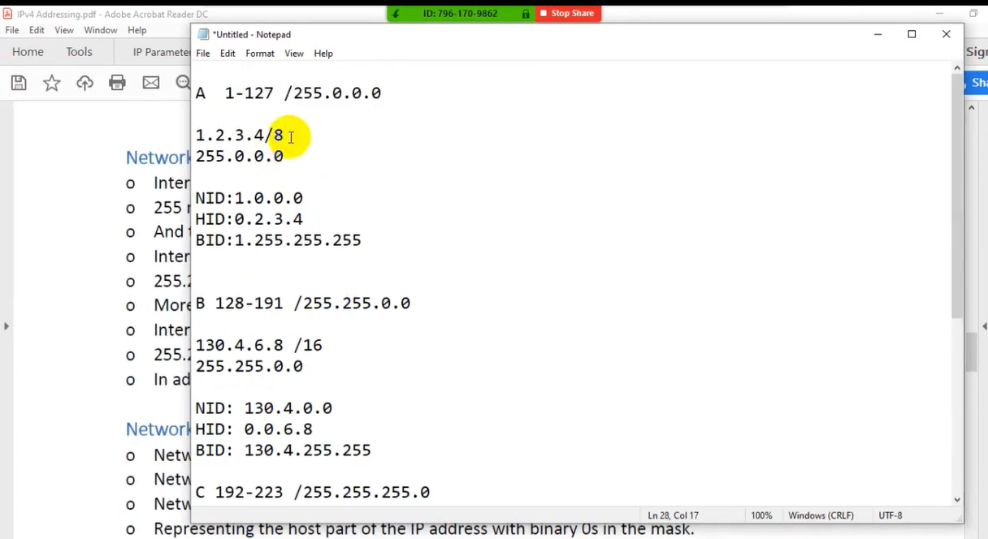

* Numerically 256 (2^8) devices can be connected with each other using class C IP address that range include [192,223] but actually only 254 devices connect because 192.1.1.0 is the network id and 192.1.1.255 is broadcast id so these ips excluded.

**Network Mask:**

* Network mask or NetMask is a 32-bit binary number.
* Network mask is usually written in dotted-decimal format.
* Network mask defines the size of the host part of an IP address,
* 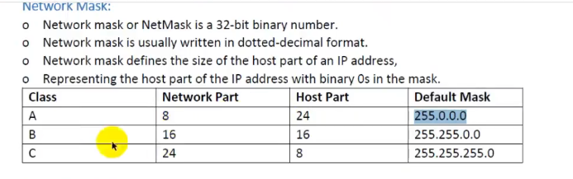Representing the host part of the IP address with binary os in the mask.

**Network Address**

* Network address or network number is a number that uses dotted -decimal notation.
* The number it represents all hosts in a single Class A. B. or C IP network.
* For example, an IP address 132.168.0.1 with network\ mask 255.255.255.0.
* the give IP addre6s. the network address will be 192.168.0 0.
* Network\; address, use logical AND operation between IP address network mask
* For example, an IP address 192.168.0.1 with network mask« 255.255.255.0,
* Convert the IP address 192.168.0.1 to binary format.
* We get 11000000 10101000 00000000 0000000L
* Logical AND operation we get 11000000 10101000 00000000 00000000.

**Private Addresses**

* Private IP addresses are used inside the LAN for Private Communication.
* Private IP Addresses are also called Non Routable IP addresses.
* Specific address ranges within Class A, Class B, & Class C reserved for private networks.
* A private IP address is a non-internet facing IP address on an internal network.
* Large companies use Class A as it allows more than 16 million hosts.
* 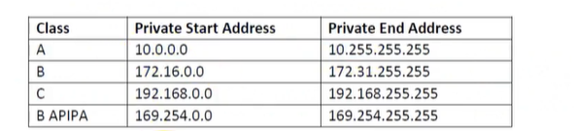Class B manages 16,384 hosts per network where Class C is used 254 hosts.

**APIPA**

* APIPA stand for Automatic Private IP Addressing.
* Windows computer assign itself an IP address if a DHCP is not available.
* For example, this could occur on a network without a DHCP server.
* On a network, if a DHCP server is temporarily down for maintenance.
* With this feature, a Windows computer can assign itself IP address.
* If a DHCP server is not available or does not exist on the network.
* This feature makes configuring and supporting LAN running TCP/IP less difficult.

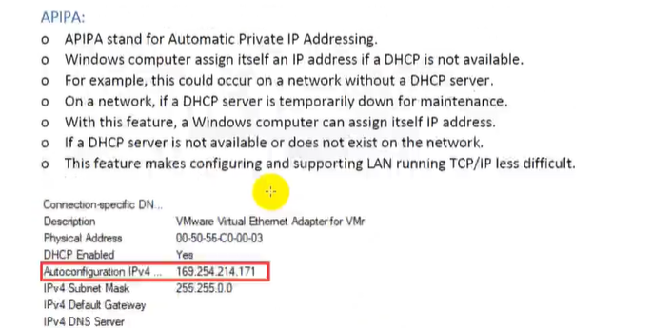

**Class Full IP Address:**

* 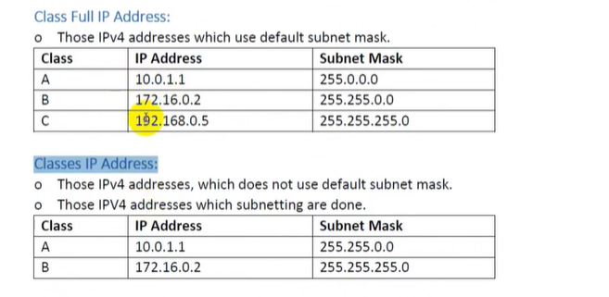Those IPv4 addresses which use default subnet mask.

**Classes IP Address**

* Those IPv4 addresses, which does not use default subnet mask.
* Those IPV4 addresses which subnetting are done.

